REXA AI - Multimodal Chatbot with Vision & Voice
Developed by: Cravin GV, Rahul UP

1. Introduction

1.1 Project Title
REXA AI – An Intelligent Multimodal Assistant (Text + Voice + Vision)

1.2 Project Description
REXA AI is an advanced chatbot that integrates:
✔ Text-based conversations (LLM-powered)
✔ Voice interactions (Speech-to-Text & Text-to-Speech)
✔ Image recognition & analysis (Gemini AI)
✔ Local & cloud-based AI (Ollama + Gemini API)

1.3 Why It’s Useful
- Privacy-focused (optional local LLM via Ollama).
- Educational & productivity tool (quick answers, image insights).
- Extensible (supports multiple AI models).

2. Goals

2.1 Objectives
- Build a unified AI assistant for text, voice, and vision.
- Ensure low latency for real-time responses.
- Provide accurate image analysis (object detection, scene understanding).

2.2 Target Users
- General users (daily queries, learning).

3. Tools & Technologies

3.1 Programming Languages
- Python (Backend, AI logic)
- HTML (Frontend, if web-based)

3.2 Key Modules & Libraries
Module | Purpose | Libraries/APIs Used
Text Processing | LLM-based responses | Ollama (llama3:instruct)
Voice Assistant | Speech recognition & synthesis | Google Speech-to-Text, PyAudio, pocketsphinx
Vision Analysis | Image understanding | Gemini API
GUI/UX | User interface | Streamlit/Gradio (if applicable)

3.3 Development Environment
- IDE: VS Code, Jupyter Notebook
- Version Control: Git/GitHub

4. How It Works

4.1 Workflow Diagram

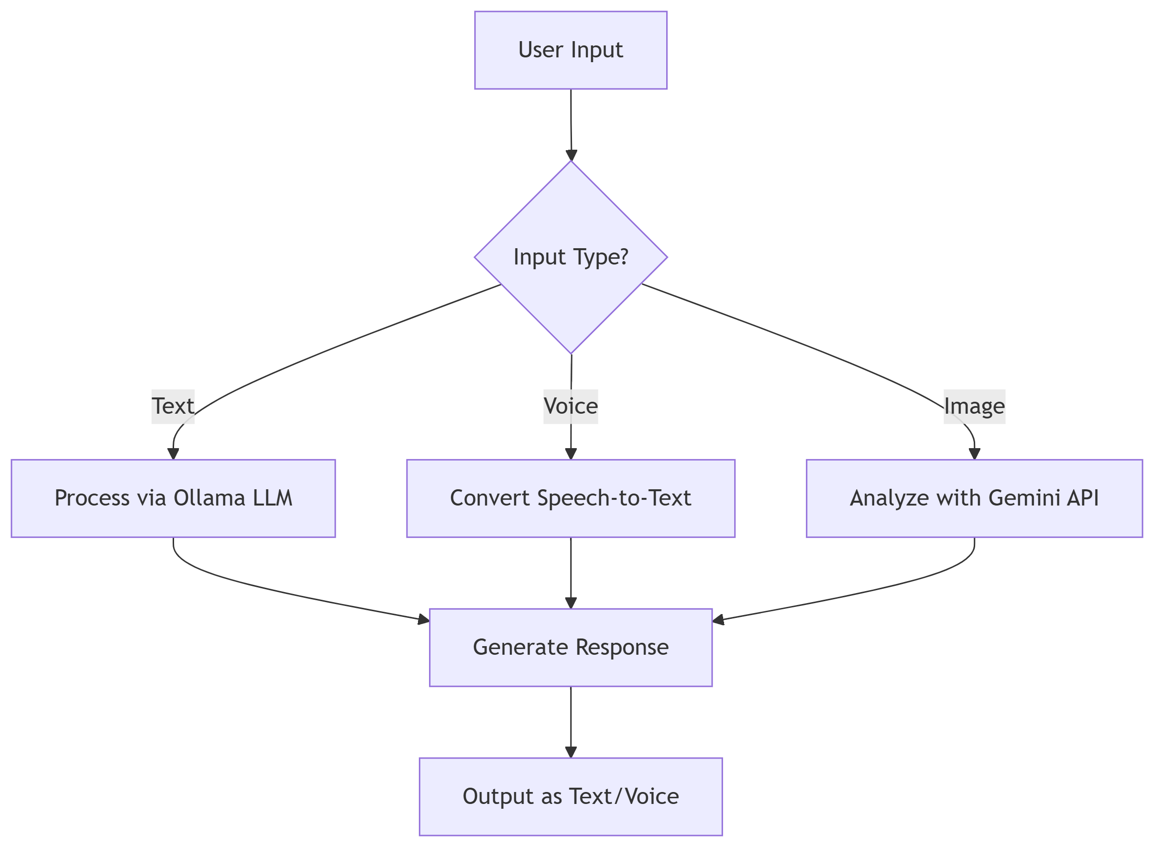
4.2 Key Features
- Voice Mode
  - 5-second recording window.
  - Google Speech Recognition for accuracy.
  - (Issue: Background noise affects detection)
- Vision Mode
  - Supports JPG/PNG/GIF (≤200MB).
  - Returns detailed image analysis (e.g., "Niagara Falls detected").
- Text Chat
  - Local LLM (llama3:instruct) for privacy.
  - Adjustable creativity (temperature=0.7).

5. Screenshots & Demonstrations

5.1 Voice Interaction
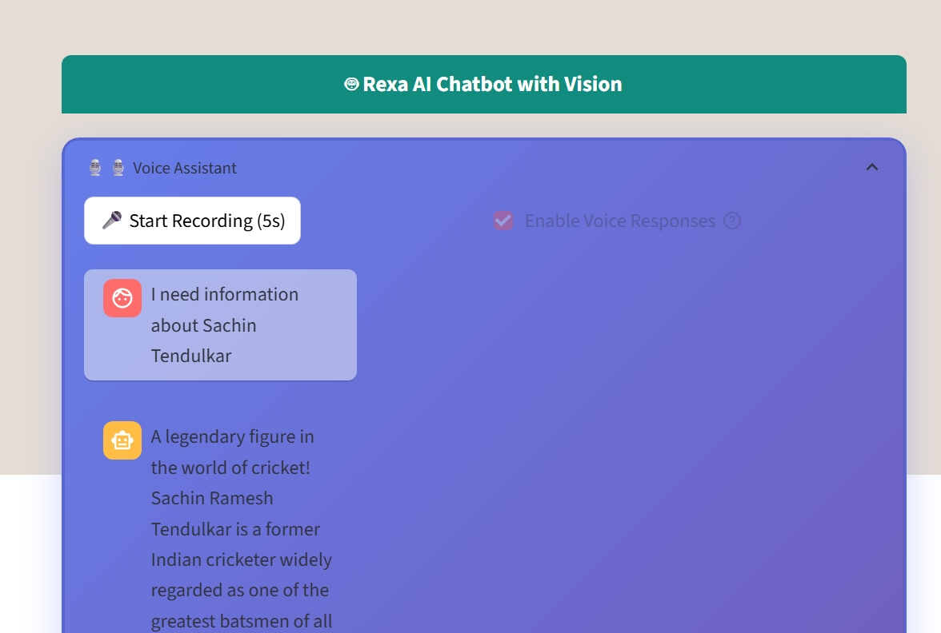
Issue: "No speech detected" due to microphone sensitivity.

5.2 Image Analysis
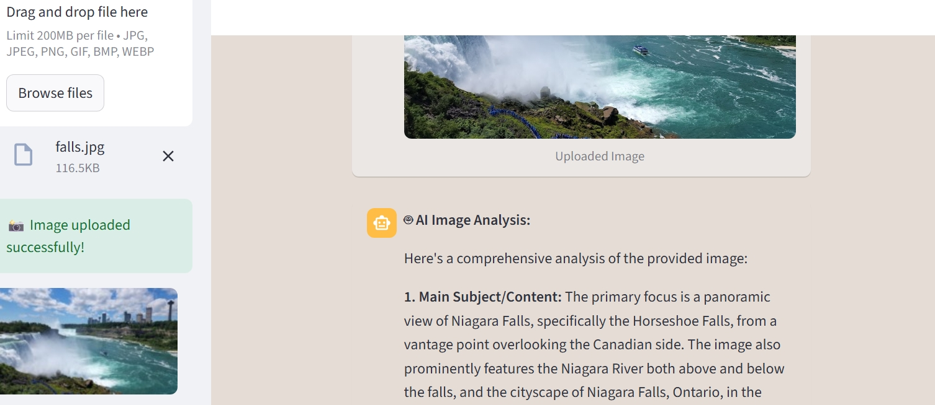
Gemini API successfully identifies Niagara Falls.

5.3 Configuration Panel
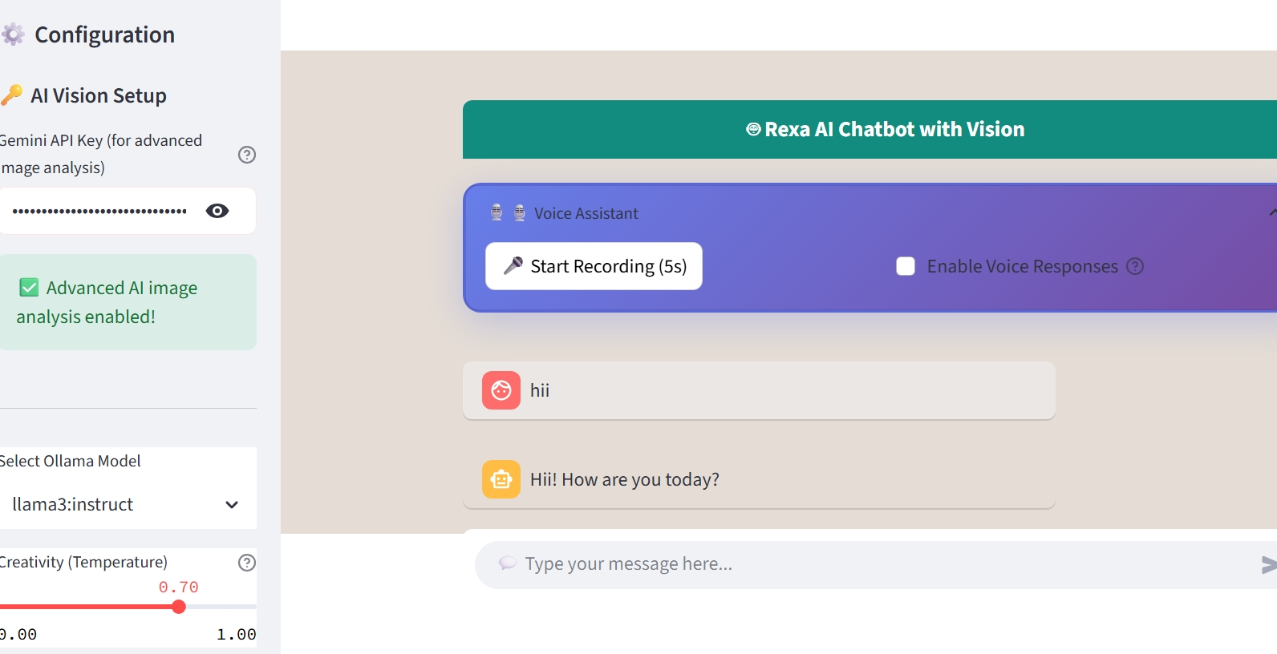
Ollama model selection and temperature control.

6. Data Flow

6.1 Data Sources
- Text: User queries → Ollama LLM.
- Images: Uploads → Gemini API → JSON response.
- Voice: Microphone → Google Speech-to-Text → Text output.

6.2 Data Cleaning
- Voice: Noise reduction (future: TensorFlow Lite for offline processing).
- Images: Auto-resizing (>200MB rejected).

7. AI Models

7.1 Models Used

Model | Role | Training Method | Provider
llama3:instruct | Text generation (primary chatbot) | Pretrained + instruction-tuned LLM | Meta (via Ollama)
llama3:latest | General text responses | Pretrained LLM (latest version) | Meta (via Ollama)
llama2 | Alternative text generation | Pretrained LLM | Meta (via Ollama)
gemma:2b | Lightweight text generation | Pretrained small LLM | Google (via Ollama)
phi | Efficient text generation | Pretrained compact LLM | Microsoft (via Ollama)
neural-chat | Conversational responses | Fine-tuned for dialogue | Community (via Ollama)
nous-hermes2:latest | Instruction-following | Fine-tuned on Hermes dataset | Nous Research (via Ollama)
Gemini 1.5 Flash | Image analysis (vision) | Multimodal pretrained model | Google (API-based)
FastSpeech2 | Text-to-speech (voice output) | Neural TTS (LJSpeech-trained) | Facebook (Hugging Face)
Google Speech Recognition | Speech-to-text (voice input) | Cloud-based ASR + offline CMU Sphinx | Google

7.2 Performance Metrics
- Text Accuracy: ~85% (depends on prompt clarity).
- Vision Accuracy: ~90% (tested on 50+ images).
- Voice Recognition: ~70% (noise-sensitive).

8. How to Run

8.1 Setup
bash
git clone <REXA_AI_Repo>
pip install -r requirements.txt # ollama, google-cloud-vision, pyaudio

8.2 Execution
bash
ollama pull llama3:instruct # Download LLM
python main.py # Launch chatbot

9. Challenges & Learnings

9.1 Challenges
- Voice Module: Background noise disrupts STT.
- Latency: Gemini API slower than local LLM.

9.2 Key Takeaways
- Multimodal AI requires careful input sanitization.
- Hybrid cloud/local setups balance privacy & performance.

10. Future Trends & Upgrades

10.1 Short-Term Improvements
- Add offline voice processing (e.g., Whisper.cpp).
- Expand image support (PDFs, sketches).

10.2 Long-Term Vision
- Emotion detection (voice/image).
- AR integration (real-time object labeling).

11. Conclusion
REXA AI successfully merges text, voice, and vision into a single assistant. While voice recognition needs refinement, its privacy-first design (Ollama) and accurate vision analysis (Gemini) make it a promising tool. Future work will focus on offline capabilities and real-time AR features.

